**HTML | <thead> align Attribute**

Last Updated : 06 Jun, 2022

The **HTML <thead> align attribute** is used to set the horizontal alignment of text content inside the table head (thead) section.

**Syntax:**

<thead align="left|right|center|justify|char">

**Note:**This attribute has been DEPRECATED and is no longer recommended.

**Attribute Value:**

* **left:** It sets the text left-align.
* **right:** It sets the text right-align.
* **center:** It sets the text center-align.
* **justify:** It stretches the text to set the width of all lines equal in table head.
* **char:** It sets the text-align to a specific character.

**Example:**

**html**

|  |
| --- |
| <!DOCTYPE html>  <html>    <head>      <title>          HTML thead align Attribute      </title>        <style>          h1 {              color: green;          }          thead {              color: blue;          }          table, tbody, td {              border: 1px solid black;              border-collapse: collapse;          }      </style>  </head>    <body>      <center>          <h1>GeeksforGeeks</h1>          <h2>HTML thead align Attribute</h2>            <table>              <!-- thead tag starts from here -->              <thead align="char" valign="bottom"                          char="M">                  <tr>                      <th>Name</th>                      <th>User Id</th>                  </tr>              </thead>              <!-- thead tag ends here -->                <tbody>                  <tr>                      <td>Ram</td>                      <td>@ram_b</td>                  </tr>                  <tr>                      <td>Shashank</td>                      <td>@shashankla</td>                  </tr>              </tbody>          </table>      </center>  </body>    </html> |

**Output:**

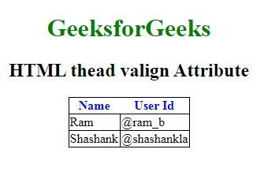

**Supported Browsers:** The browser supported by HTML <thead> align attribute are listed below:

* Google Chrome
* Internet Explorer
* Firefox
* Safari
* Opera